 INDIAN SCHOOL AL WADI AL KABIR
Worksheet, 2026-27
Class: XII | SUB: INFORMATICS PRACTICES | Date of Completion:
Worksheet No:4 | TOPIC : Data Visualization using Matplotlib

- Write Python code to plot a bar chart for India’s medal tally as shown below: Also give suitable python statement to save this chart.
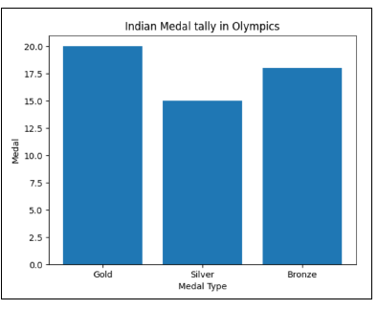
- Write a python program to plot a line chart based on the given data to depict the changing weekly average temperature in Delhi for four weeks.
Avg_week_temp=[40,42,38,44]
- Write a program to draw line charts for the following with suitable label in the Xaxis, Y-axis and a title. Show the unemployment rate from 1930 to 2020
Year = [1930,1940,1950,1960,1970,1980,1990,2000,2010,2020]
Unemployment_Rate = [9.8, 12, 8, 7.2, 6.9, 7, 6.5, 6.2, 5.5, 9.3]
- Ms Deepthi wants to show the given set of values of subjects on x-axis and number of candidates appearing for the exam on y-axis on a graph. Help Deepthi to plot a line graph .
Subjects =[‘Accounting’, ‘Law’,’Home Science’,’Business Administration’]
No_of _candidates=[123, 97, 35,125]

- Consider the following graph. Write the code to plot it.
- Write a Python program to plot a horizontal bar graph to depict the popularity of various programming languages. Label the graph with x-axis, y-axis and title.
Programming languages: Python, C++, Java, Perl, Scala, Lisp
Usage : 10, 8, 6, 4, 2, 1
- Create a bar graph of the following data with title and labels on X axis and Y axis.
Country GDP_Per_Capita
USA 45000
Canada 42000
Germany 52000
UK 49000
France 47000
- Consider the following graph. Write the code to plot it.
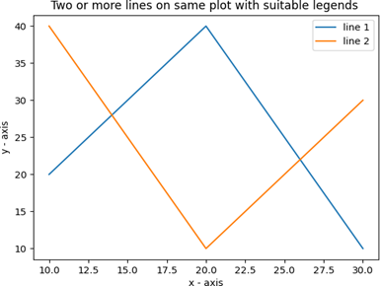

- The number of students in 7 different classes is given below. Represent this data on the bar graph.
Class | 6th | 7th | 8th | 9th | 10th | 11th | 12th
Number of Students | 130 | 120 | 135 | 130 | 150 | 80 | 75

- Write a program to generate a histogram with the following values
X=[25,28,35,46,57,68,73]
Include the following parameters/arguments along with histogram:
- It should be a horizontal histogram
- Number of bins should be 20

- The heights of 10 students of eighth grade are given below:
Height_cms=[145,141,142,142,143,144,141,140,143,144]
Write suitable Python code to generate a histogram based on the given data, along with an appropriate chart title and both axis labels. Also give suitable python statement to save this chart.

